* What is the correlation (R2 value) between sales and income?
* What is the linear regression formula to predict customer sales and customer incomes?

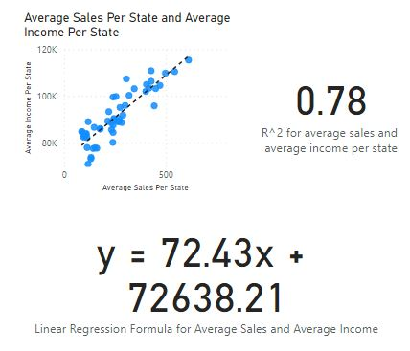

* What is the correlation (R2 value) between customer ratings and product return rate?

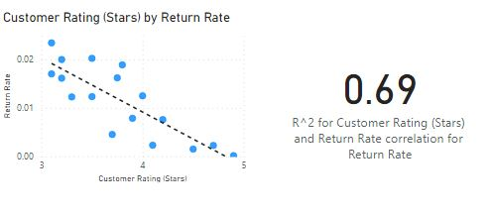

* Which customer do you predict has the highest income?

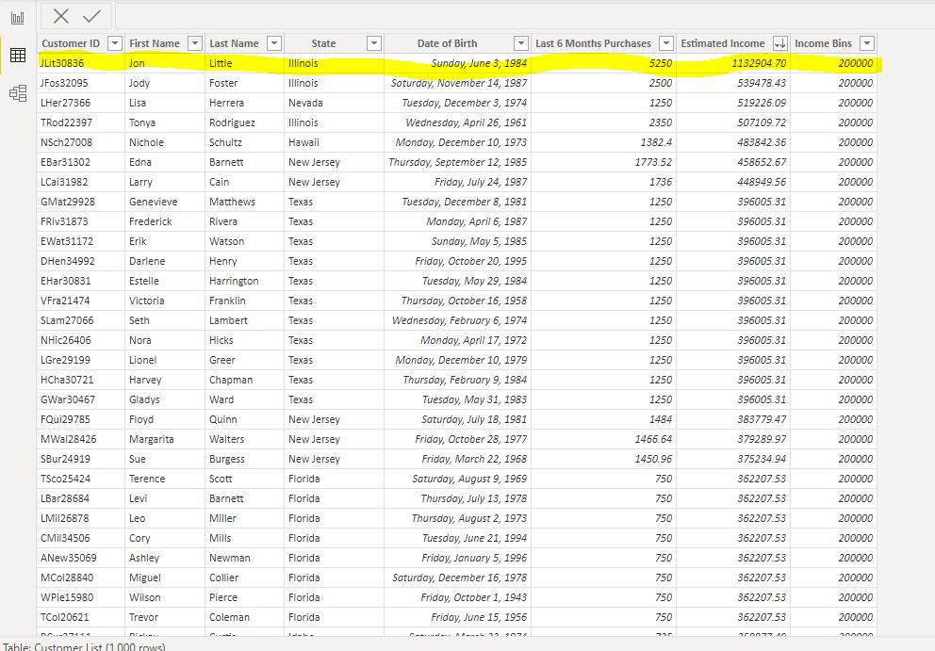

* Which product will be advertised the most?

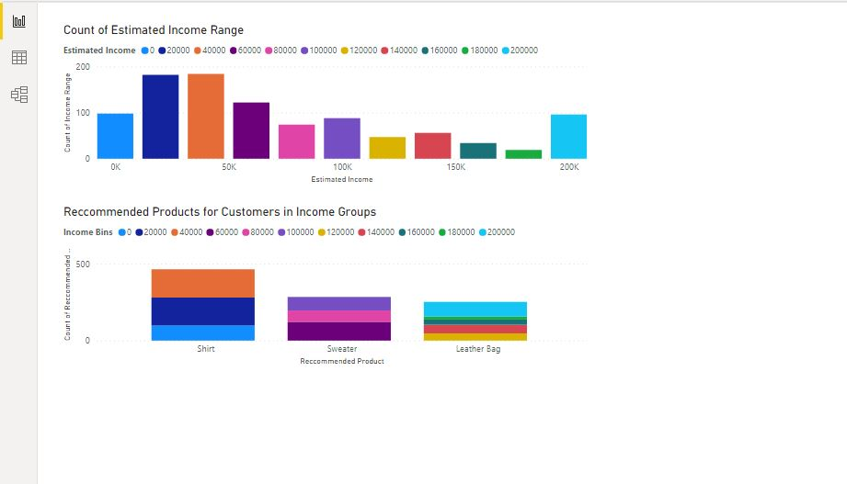

Average Population and Bubble Map

